**FRONTEND (Return Item Forms Tab)**

* **Return Item Details:**

The picture below is to view the return item details which you can view the item you have been created. It shows the reference table 1.1

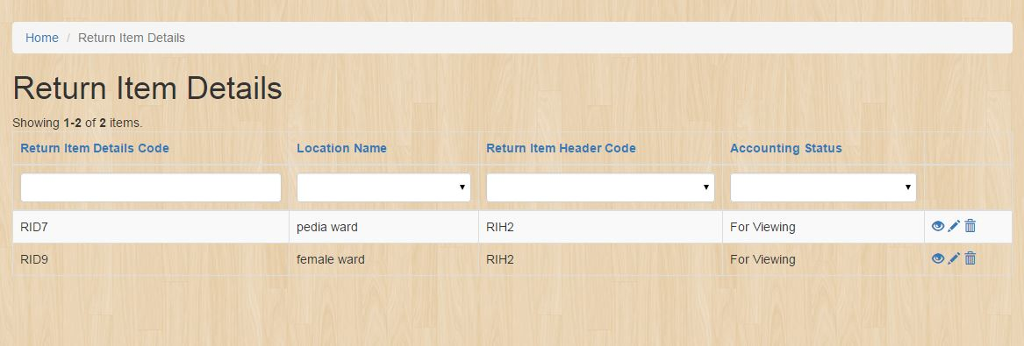

To view the return item details click this button:



* **Return Item Header**

The Return Item Header at the frontend of the system is for accounting department for viewing purposes for the billing of the patient.

The picture below is the view of the Return Item Headers which is the user can search for the patient name and view of what are the items that have been return by the patient. It shows the reference table 1.1

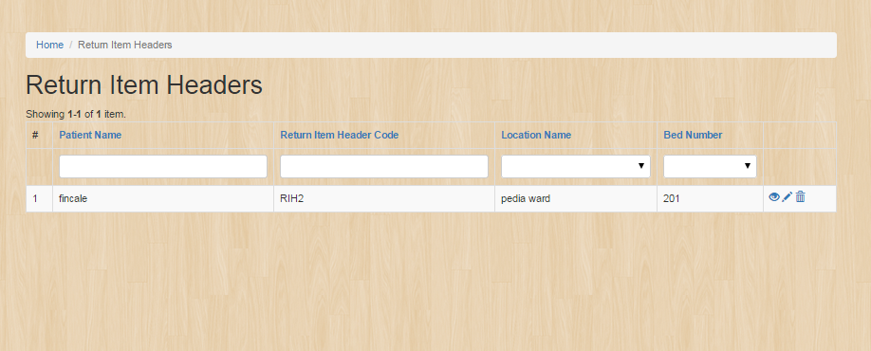

To view the details click the  and the image below shows the details.

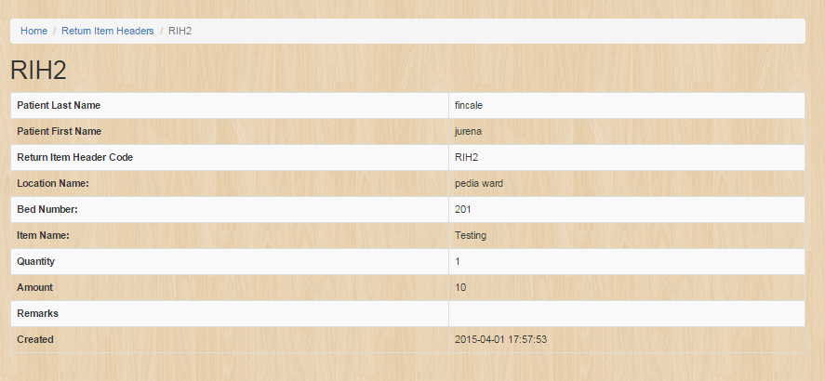

**Backend User Management Tab**

* **User**

**Backend User Table:**

User table is to manage the user accounts for each employee.

The picture below is the view of the user table which is you can create, update and delete the item you will create. It shows the reference table 1.1

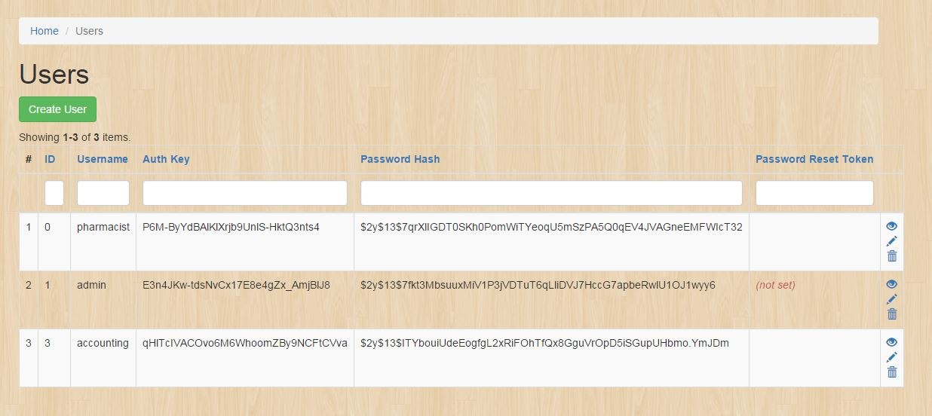

To create a Position just simply clicks this button:



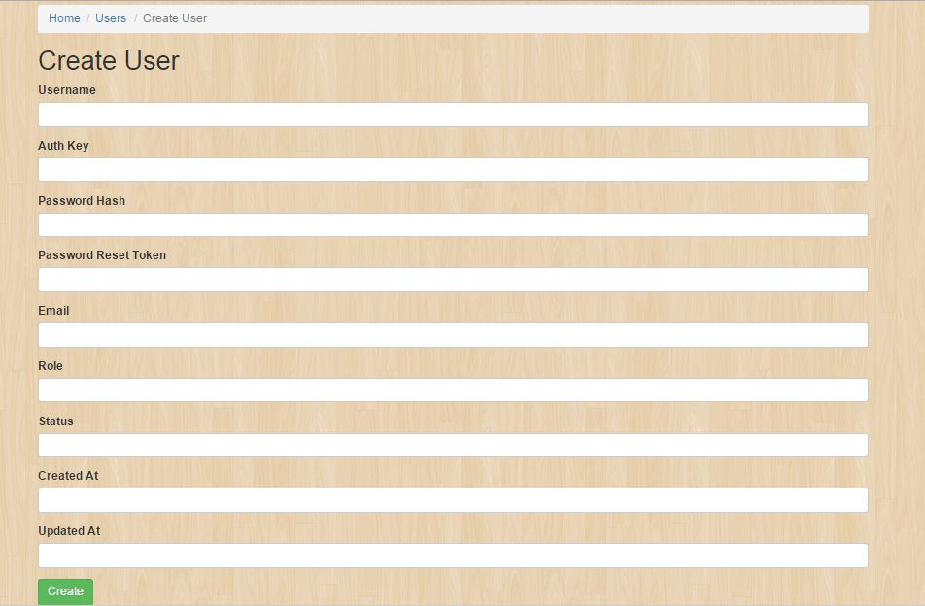

It will display these fields:

* **Manage Employee Records**

Under the **User management** navigation bar, go to **Manage Employee Records** and the image below should be prompted which you can create, update and delete the item you will create .It shows the reference table 1.1.

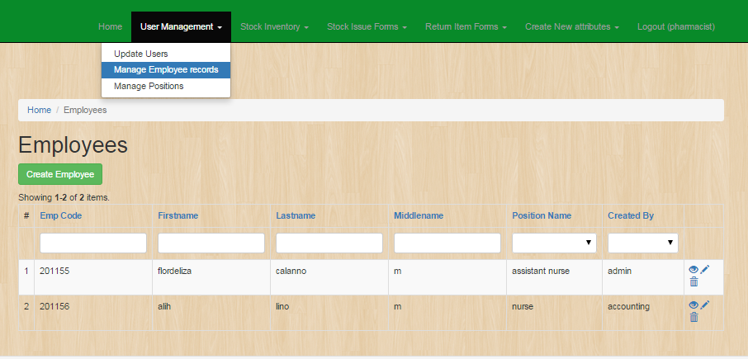

To create **Employee Record** click the button same as the image below:



And a new page like the image below would be open as you click the **create employee** button. Fill out the fields with appropriate data and click the button **create.**

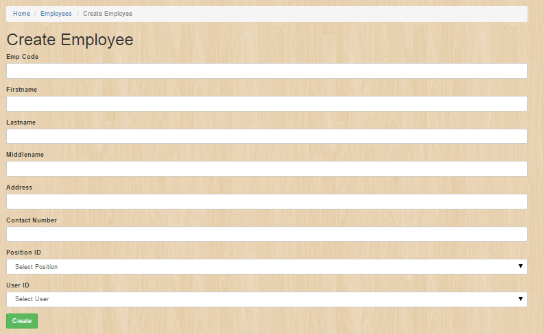

As you succesfully created employee record, an image below should be the result.

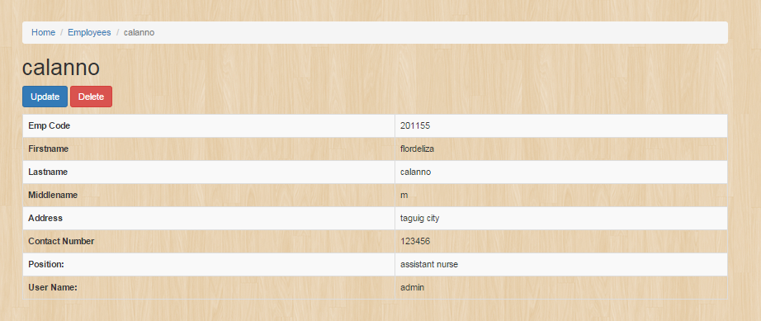

* **Manage Position**

Position table is to manage the positions for each employee.

The picture below is the view of the position table which is you can create, update and delete the item you will create. It shows the reference table 1.1

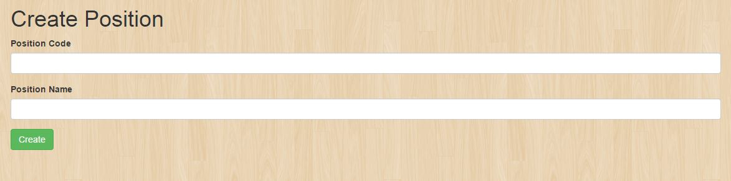

To create a Position just simply clicks this button:



It will display these fields:



**Stock Inventory Tab**

* **Stock Inventory Record**

Under the **Stock Inventory** navigation bar, go to **Stock Inventory Record** and the image below should be prompted which you can create, update and delete the item you will create .It shows the reference table 1.1.

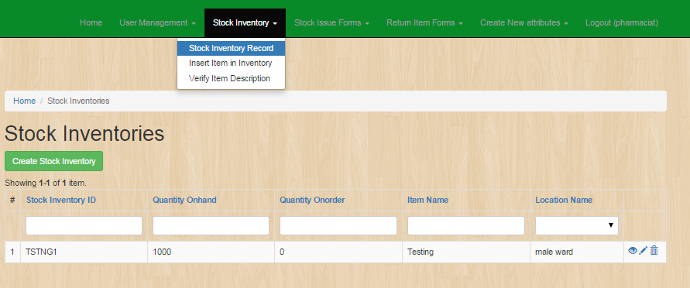

To create **Stocks Inventory** click the button same as the image below:



And a new page like the image below would be open as you click the **create Stock Inventory** button. Fill out the fields with appropriate data and click the button **create.**

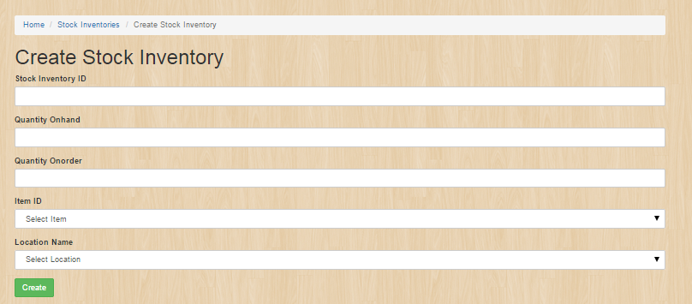

As you succesfully **created Stock Invetories**, an image below should be the result.

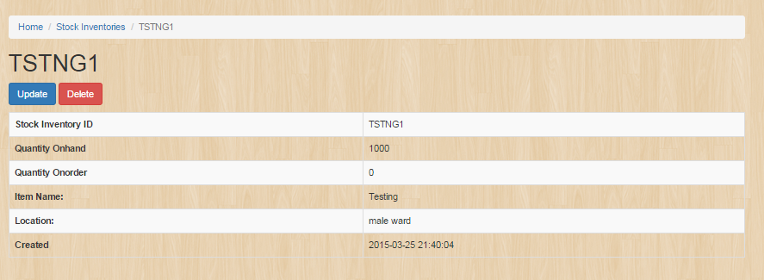

* Item Description:

The picture below is to view the item description which is you can create, update and delete the item which you will create. It shows the reference table 1.1

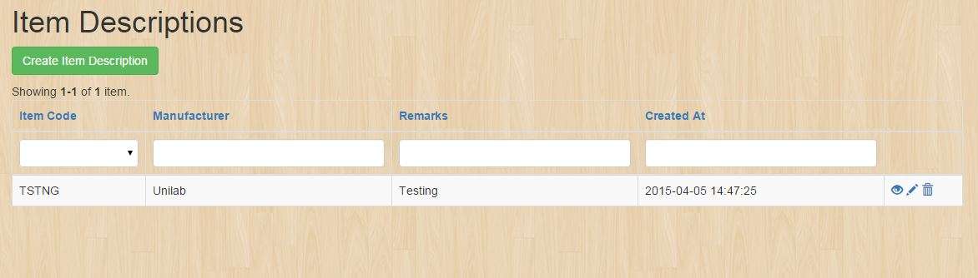

To create an item description click this button:



Fill up this form to create an entity in the item description:

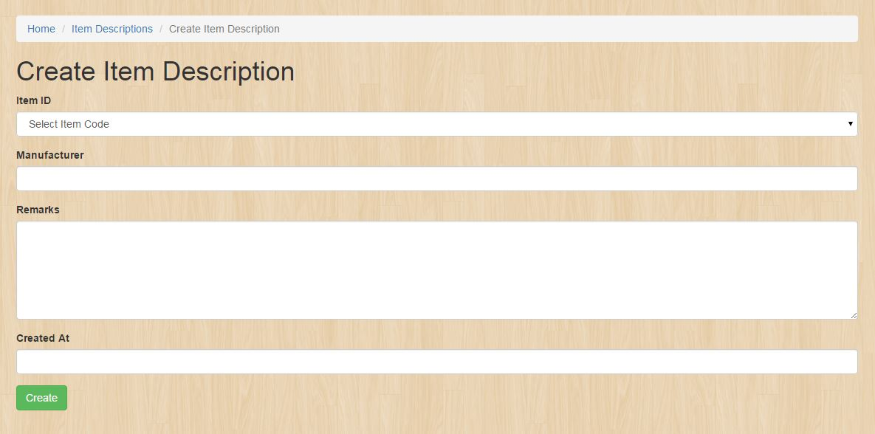

**Stock Issue Form Tab**

* **Stock Issue Details**

The picture below is to view the stock issue details which is you can create, update and delete the item you will created .It shows the reference table 1.1

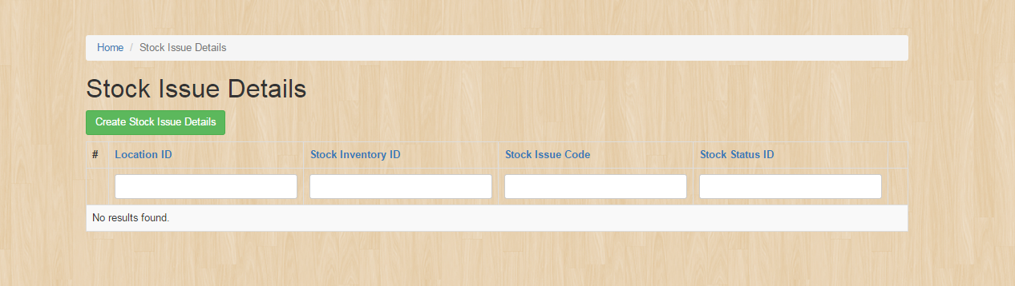

To create a stock issue details click this button.



Fill up this form to create an entity in the stock issue details.

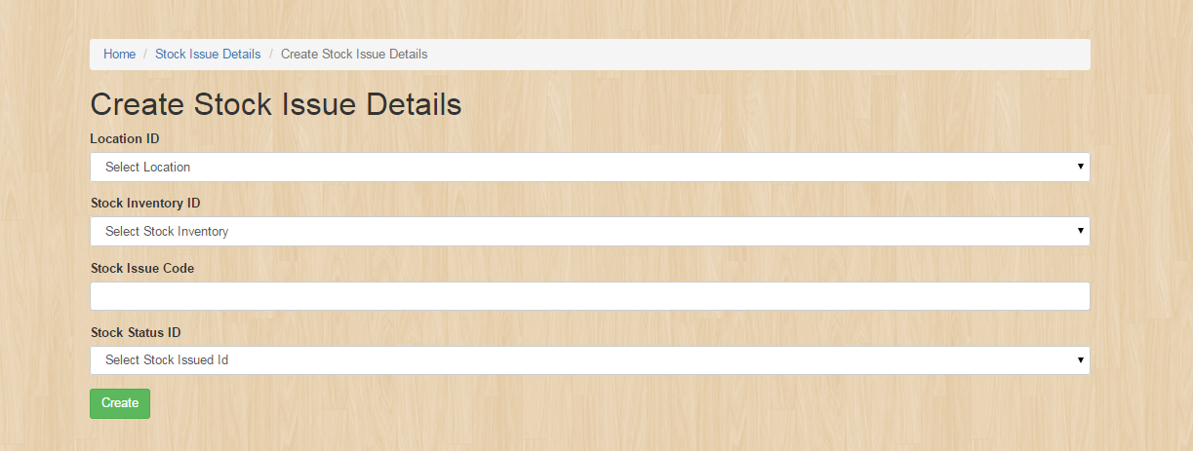

To edit or update the entity see the reference table 1.1 then click the update button.

* **Stock Issue Header**

**Backend Stock Issue Header Table:**

Stock Issue Header table is to manage the all the stocks of the inventory.

The picture below is the view of the stock issue header table which is you can create, update and delete the item you will create. It shows the reference table 1.1

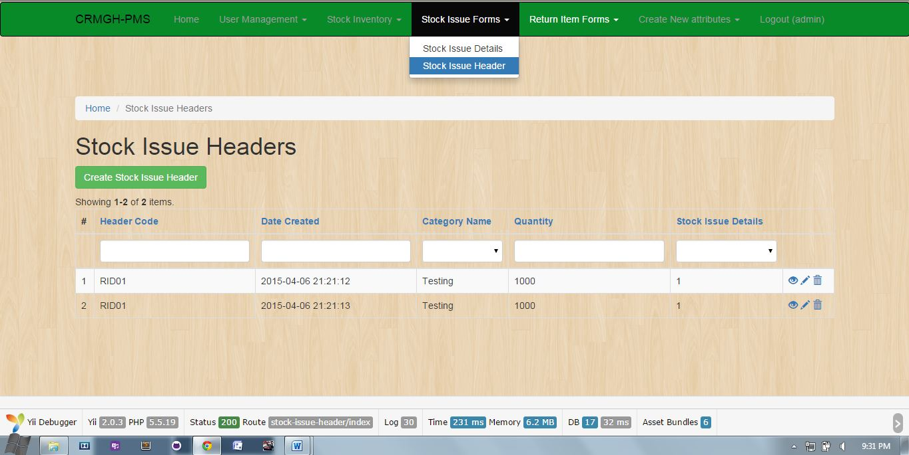

To create a Stock Issue Header just simply clicks this button:



It will display these fields:

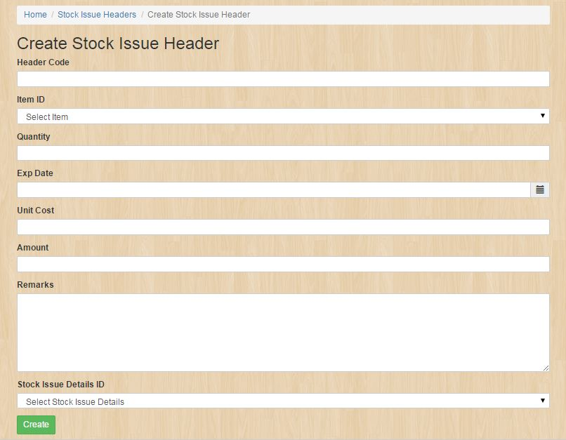

**Return Item Form Tab**

* **Stock Issue Details**

The picture below is to view the stock issue details which is you can create, update and delete the item you will created .It shows the reference table 1.1



To create a stock issue details click this button.



Fill up this form to create an entity in the stock issue details.



To edit or update the entity see the reference table 1.1 then click the update button.

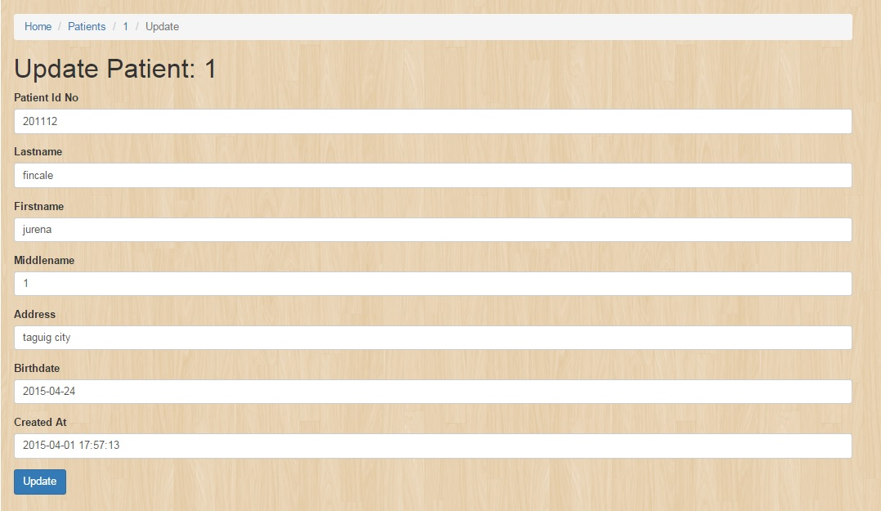

* **Return Item Details**

Under the **Return Item Forms** navigation bar, go to **Return Item Details** and the image below should be prompted which you can create, update and delete the item you will create .It shows the reference table 1.1.

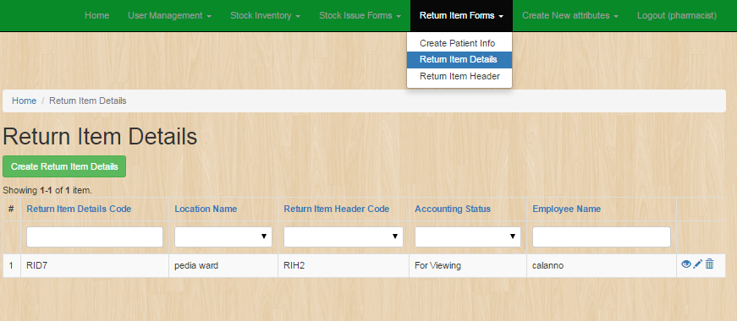

To create **Return Item Details** click the button same as the image below:



And a new page like the image below would be open as you click the **create Return Item Details** button. Fill out the fields with appropriate data and click the button **create.**

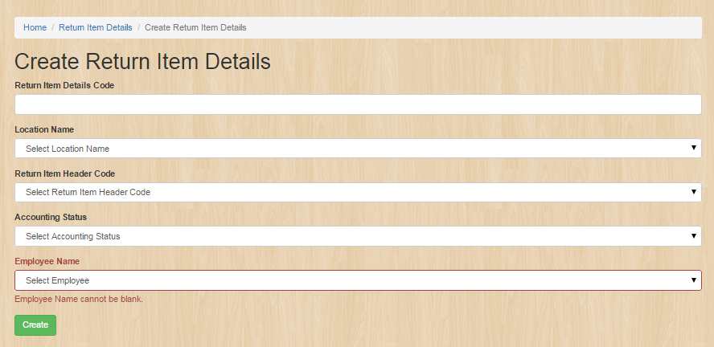

As you succesfully **created Return Item Details**, an image below should be the result. 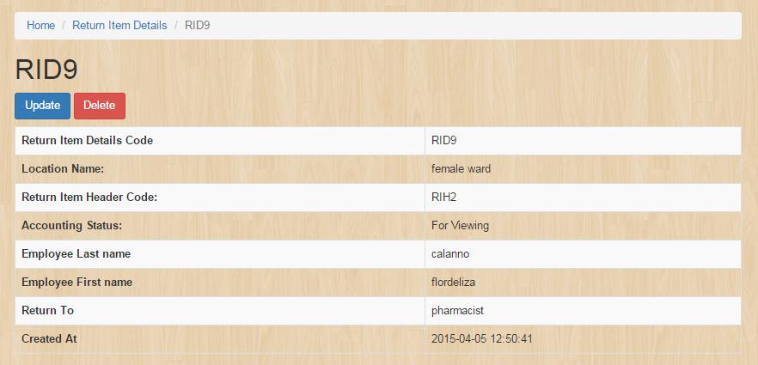

* **Return Item Header**

The picture below is to view the item category which is you can create, update and delete the item you will created .It shows the reference table 1.1

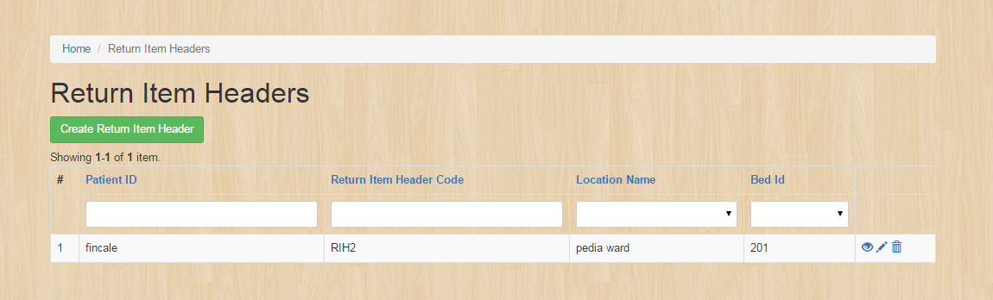

To create a Return item header details click this button.



Fill up this form to create an entity in the Return Item Header.

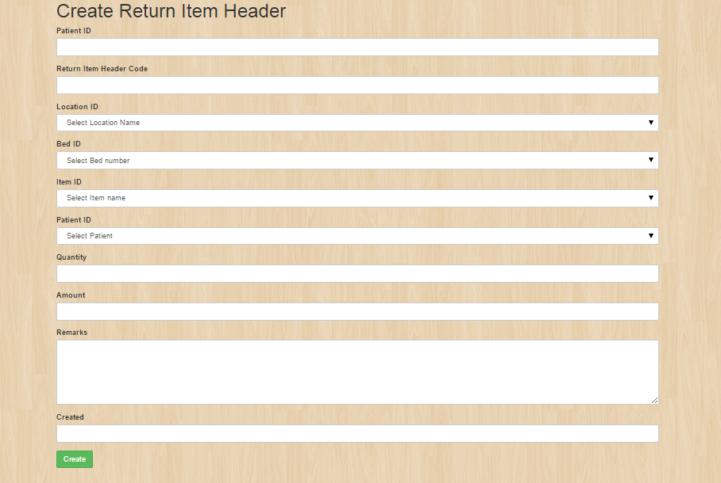

To edit or update the entity see the reference table 1.1 then click the update button.

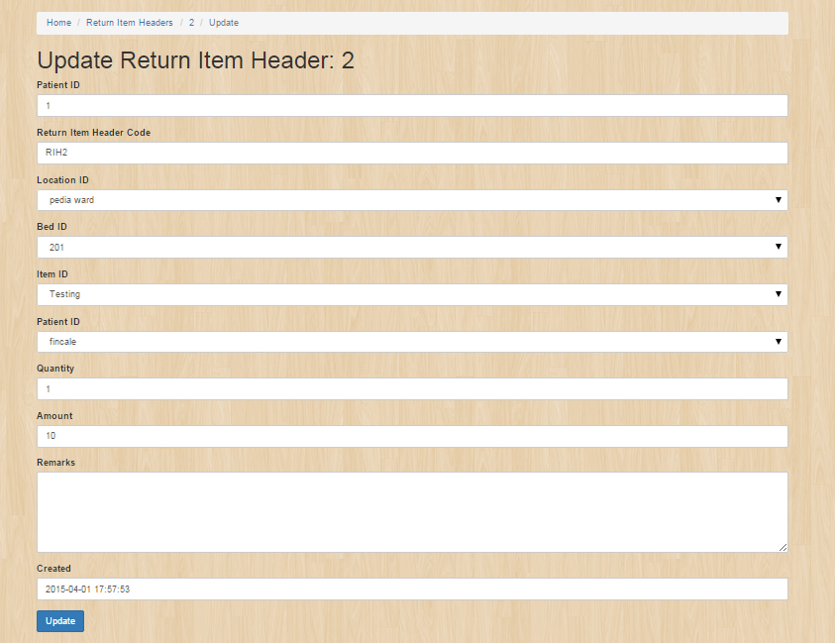

**Create New Attributes Tab**

* **Stock Status**

Stock status is to manage the status of the stocks.

The picture below is the view of the stock status which is you can create, update and delete the item you will created .It shows the reference table 1.1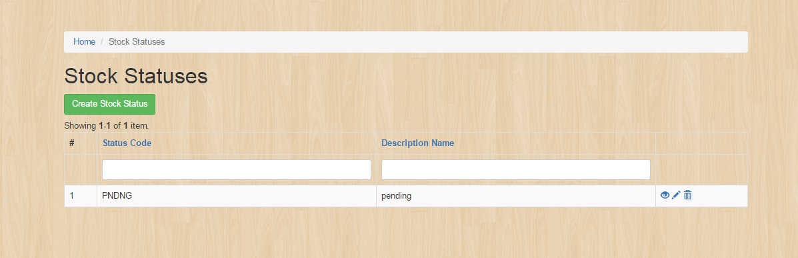

To create a Stock statuses just simply click this button

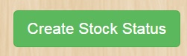

It will appeared this fields

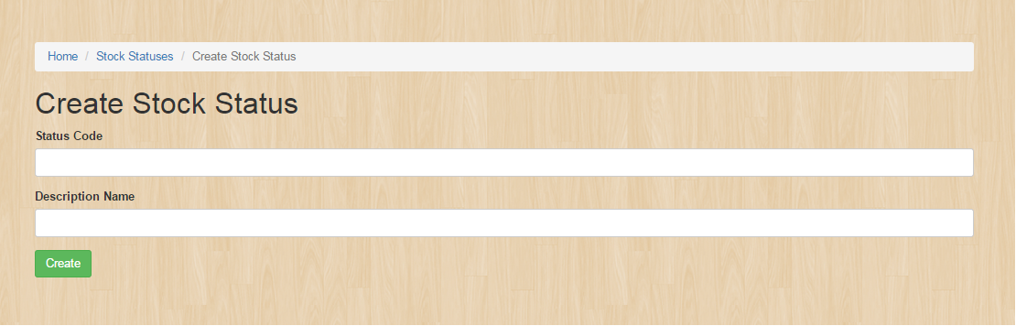

To edit or update the entity see the reference table 1.1 then click the update button.

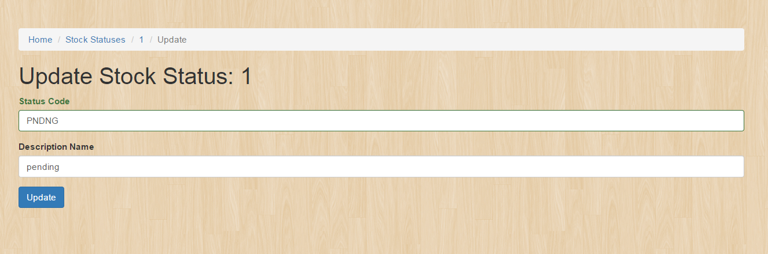

* **Location**

The picture below is to view the Location table which is you can create, update and delete the item you will create. It show the reference table 1.1

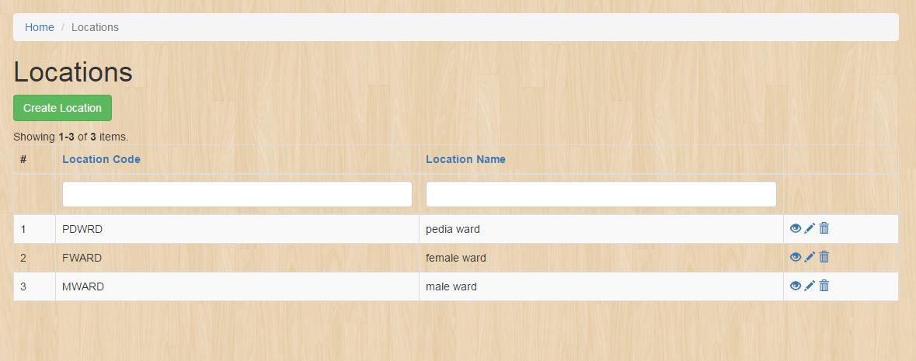

To create a Location, click this button:



Fill up this form to create an entity in the Location table:

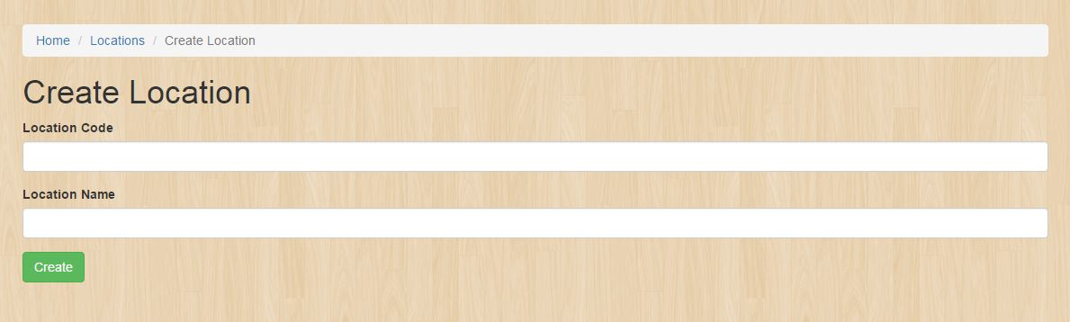

* **Item Category**

The picture below is to view the item category which is you can create, update and delete the item you will created .It shows the reference table 1.1

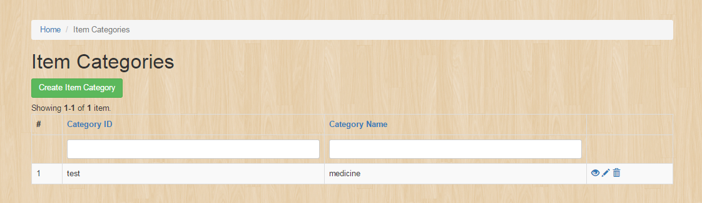

To create an item category details click this button.



Fill up this form to create an entity in the Item category.

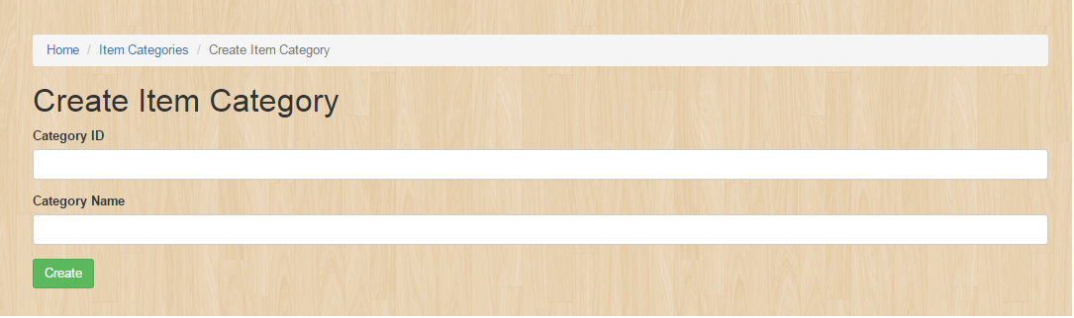

To edit or update the entity see the reference table 1.1 then click the update button.

